**Internship Report**

**On**

**Financial Forecasting Dashboard using Power BI**

**By**

**KEERTHI SUREKA**

**(30th Sep 2024 – 02nd Dec 2024)**



**Infosys Springboard Internship 5.0**

**Submission Date: 26th Nov 2024**

**Acknowledgment**

The completion of this internship project, “**Financial Forecasting Dashboard using Power BI**,” has been an enriching and transformative experience. I am profoundly grateful to my mentor, **Janarthanan R**, whose unwavering guidance and expertise have been instrumental in shaping this project. Their constructive feedback and encouragement were a constant source of motivation during challenging phases of the work.

I would also like to extend my heartfelt thanks to **Infosys Springboard** for offering me this opportunity and providing a conducive environment to enhance my technical and analytical skills. The collaborative work culture and access to resources enabled me to explore innovative ways of solving complex problems.

I am deeply indebted to my academic institution and my professors, who laid the foundation for my learning journey and provided continual support throughout this internship. Special thanks to my peers and colleagues for their collaboration, insightful discussions, and camaraderie. Their inputs not only enriched my project but also made this journey a memorable experience.

Finally, I am grateful to my family and friends for their encouragement and support, which allowed me to dedicate myself entirely to this project. This acknowledgment serves as a small token of my appreciation for everyone who contributed to the successful completion of this internship.

**Abstract**

The project “**Financial Forecasting Dashboard using Power BI**” delves into the realm of predictive analytics to provide actionable insights into financial data. As organizations increasingly rely on data-driven decisions, this project aims to equip stakeholders with tools and methodologies to forecast future financial trends accurately. The core objective was to leverage Power BI, a leading business intelligence platform, to process historical data, analyze key financial metrics, and project future outcomes.

The project follows a structured workflow, starting with data preparation and cleansing, followed by the creation of interactive visualizations to identify patterns in revenue, costs, and profits. Subsequently, forecasting models were implemented to predict financial performance using built-in tools in Power BI and custom calculations via DAX and Power Query. The culmination of this work is an interactive dashboard that consolidates historical trends, current performance, and forecasted data into a unified platform.

The outcomes demonstrate how visual analytics and forecasting models can simplify complex financial datasets, highlight critical insights, and guide strategic planning. By addressing challenges such as data inconsistencies and learning curve barriers, the project successfully presents a framework for continuous improvement and scalability in financial forecasting. Future iterations of the project could incorporate real-time data integration and advanced machine learning models for even greater predictive accuracy.

**Table of Contents**

|  |  |  |
| --- | --- | --- |
| **Sl. No.** | **Title** | **Pg. No.** |
| 1 | Introduction | 1 |
| 2 | Project Statement | 2 |
| 3 | Modules Implemented | 2 |
| 4 | Work Done | 4 |
| 5 | Tools and Technologies | 7 |
| 6 | Key Outcomes | 11 |
| 7 | Screenshots and Visuals | 14 |
| 8 | Challenges and Learnings | 17 |
| 9 | Conclusion | 20 |
| 10 | Future Scope | 21 |
| 11 | References | 24 |

**Introduction**

In today’s competitive business landscape, organizations are under constant pressure to make informed decisions that drive growth and profitability. Financial forecasting serves as a vital tool in this endeavor, enabling businesses to anticipate future trends, allocate resources efficiently, and mitigate risks. This internship project, “**Financial Forecasting Dashboard using Power BI**,” was designed to address the growing need for reliable, data-driven forecasting solutions.

The project utilizes Power BI, a versatile business intelligence tool known for its robust visualization and analysis capabilities. Power BI’s user-friendly interface, coupled with advanced functionalities like **DAX calculations and Power Query**, makes it an ideal platform for handling large datasets and generating insights. This project involved analyzing historical data to identify patterns in revenue, expenses, and profits across various segments and time periods. By implementing forecasting models, the project aimed to project future trends and provide actionable recommendations to stakeholders.

The **scope** of this project extends beyond basic analytics, encompassing the design and development of an interactive dashboard. This dashboard consolidates historical data, key performance indicators, and forecasted metrics, offering a comprehensive view of organizational financial health. By enabling users to explore data dynamically, the dashboard serves as a valuable decision-support tool. The insights generated through this project underscore the importance of adopting modern analytics platforms to stay ahead in the competitive market.

**Project Statement**

Forecasting is a prediction with the same level of granularity as the data point used. After importing the dataset, temporal analysis via the built-in option involves using a line chart because it is essential to have a continuous temporal reference on the x-axis. On the y-axis, you will insert the aggregated measure, relative to the data point’s granularity level, for which we want to calculate the forecast.

**Modules Implemented**

* **Module 1:**

**Data Preparation (Weeks 1–3)**

The first step in any analytics project is preparing the dataset for analysis. This module focused on importing and cleaning historical financial data to ensure accuracy and consistency. Key tasks included handling missing values, correcting date formats, and structuring the dataset to enable seamless time series analysis. Columns such as revenue, expenses, profit, and date were standardized for better compatibility with Power BI’s visualization tools.

* **Module 2:**

**Creating Time Series Visualizations (Weeks 4–6)**

Visualization is at the heart of financial analysis. In this phase, various graphical representations were developed, including line charts to depict trends in revenue and profits over time, and clustered bar charts for comparing quarterly or yearly performance across segments and countries. KPIs were integrated to highlight critical metrics like profit margins and year-over-year growth rates. These visualizations provided a foundation for understanding historical trends and identifying areas of concern or opportunity.

* **Module 3:**

**Implementing Forecasting Models (Weeks 7–8)**

Forecasting was implemented using Power BI’s built-in tools, allowing for the projection of revenue and expenses based on historical patterns. For scenarios requiring greater customization, DAX and Power Query were used to create tailored calculations. This module also included comparing actual and forecasted values to evaluate model accuracy.

* **Module 4:**

**Finalizing the Dashboard (Weeks 9–10)**

The final phase involved consolidating all visualizations and forecasts into an interactive dashboard. User-friendly elements such as slicers and filters were added to enable dynamic exploration of data. The dashboard was designed to cater to both high-level executives, who require a summary view, and analysts, who need to delve deeper into specific metrics

**Work Done**

The project "**Financial Forecasting Dashboard using Power BI**" was a systematic and multi-phase endeavor aimed at transforming raw financial data into meaningful insights. The following sections detail each stage of the work completed during the internship.

**1. Data Preparation**

The foundation of the project was laid during the data preparation phase. The dataset, comprising historical financial records, was first imported into Power BI. During this step, the following tasks were completed:

* **Data Cleaning**: Inconsistencies in the dataset, such as missing values, duplicate entries, and formatting issues, were addressed. For example:
  + Missing values in the "Units Sold" column were filled using interpolation techniques, ensuring trend continuity.
  + Duplicate entries were identified and removed to prevent skewed analysis.
* **Date Formatting**: Since the project required time-series analysis, it was critical to standardize the date column. The date format was transformed to align with Power BI's built-in time intelligence functions.
* **Structuring Data**: The dataset was reorganized to include essential columns such as Date, Revenue, Profit, and Expenses. Each column was verified for consistency to ensure accurate computations.

**2. Data Analysis and Visualization**

Once the data was ready, it was analyzed and visualized using Power BI. This phase focused on creating meaningful visuals to identify patterns and trends in the historical data. The following visualizations were developed:

* **Line Charts**: Time-series line charts were created to represent trends in revenue, profit, and expenses over various time periods (monthly, quarterly, and yearly). These visuals provided insights into seasonal variations and growth trends.
* **Clustered Bar Charts**: To facilitate comparison of financial performance across different regions and segments, clustered bar charts were implemented. For instance, the bar charts compared yearly revenue across markets like Government and Midmarket.
* **Key Performance Indicators (KPIs)**: KPIs were added to highlight critical financial metrics such as:
  + Current profit margins.
  + Year-over-year (YoY) growth in revenue.
  + Average quarterly sales.

These visualizations were instrumental in understanding the data and identifying areas requiring attention, such as underperforming regions or declining segments.

**3. Forecasting Models**

The core of the project revolved around forecasting future financial trends. Using historical data, forecasting models were built in Power BI to predict key metrics like revenue and expenses. Key aspects of this phase included:

* **Built-in Forecasting**: Power BI’s built-in forecasting functionality was utilized to generate predictions based on historical data trends. Parameters like confidence intervals and forecast lengths were configured to enhance accuracy.
* **Custom Forecasting**: For more complex scenarios, custom calculations were implemented using DAX and Power Query. For example:
  + A DAX measure was created to calculate moving averages for trend smoothing.
  + Power Query was used to generate custom time-series aggregations for enhanced forecasting accuracy.
* **Comparison of Actual vs. Predicted Values**: To validate the models, actual historical data was plotted alongside forecasted values. This helped assess the accuracy of the predictions and adjust the model parameters accordingly.

**4. Dashboard Design and Development**

The final stage of the project involved consolidating all the analyses and forecasts into an interactive dashboard. This dashboard served as a comprehensive tool for financial analysis and decision-making. The steps included:

* **Layout Design**: The dashboard was designed to be intuitive and visually appealing. A clean layout was chosen, with key insights displayed prominently at the top, followed by detailed visualizations.
* **Interactive Elements**: Filters, slicers, and dropdown menus were added to enhance interactivity. Users could dynamically explore data by:
  + Selecting specific time periods (e.g., monthly, quarterly, yearly).
  + Filtering by regions, segments, or products.
* **Integration of Forecasts**: The dashboard displayed forecasted data alongside historical trends, enabling users to analyze future projections in the context of past performance.
* **Insights and Narratives**: Textual narratives were added to the dashboard, summarizing key trends and forecasts. These insights provided users with actionable takeaways at a glance.

**5. Testing and Refinement**

Before finalizing the project, the dashboard and models were rigorously tested to ensure:

* **Accuracy**: Data was cross-verified against source records to confirm reliability.
* **Responsiveness**: The dashboard was optimized for performance to handle large datasets without lag.
* **User Experience**: Feedback was sought from mentors and colleagues to refine the layout and features for better usability.

**Summary of Work**

Through these stages, the project achieved its goal of developing a robust financial forecasting solution. The work completed during the internship not only enhanced my technical skills in Power BI but also provided valuable insights into the practical challenges of financial analysis and forecasting. The interactive dashboard, with its combination of historical trends and future predictions, is a testament to the value of data-driven decision-making in modern businesses.

**Tools and Technologies**

The “**Financial Forecasting Dashboard using Power BI**” project heavily relied on a range of tools and technologies to analyze, visualize, and forecast financial data. This section provides an in-depth overview of the primary tools and technologies utilized, along with their significance and contributions to the project.

**1. Power BI**

Power BI, a powerful business intelligence tool by Microsoft, was the cornerstone of this project. Its robust features for data visualization, analysis, and interactivity made it the ideal platform for creating a financial forecasting dashboard.

**Key Features Used**:

* **Data Connectivity**: Power BI’s ability to connect to various data sources was instrumental in importing the historical financial dataset. The platform seamlessly handled large volumes of data with minimal lag.
* **Data Modeling**: The built-in data modeling features allowed for the creation of relationships between multiple tables, ensuring consistency and accuracy in analysis.
* **Visualization Tools**: A wide range of visualization options (e.g., line charts, bar charts, KPIs) were employed to represent data trends effectively.
* **Forecasting Capabilities**: Power BI’s built-in forecasting feature enabled quick predictions by analyzing historical trends. Custom forecast models were also implemented using DAX expressions.

**Advantages**:

* User-friendly interface for rapid prototyping.
* Advanced features such as slicers and filters for dynamic data exploration.
* Real-time data refresh capabilities, which can be scaled for future use.

**2. DAX (Data Analysis Expressions)**

DAX is a formula language in Power BI used for creating calculated columns, measures, and tables. It was pivotal in crafting custom calculations and enhancing the analytical capabilities of the dashboard.

**Applications in the Project**:

* **Custom Metrics**: Measures like profit margins, YoY growth, and moving averages were calculated using DAX.
* **Time Intelligence**: Functions such as TOTALYTD(), SAMEPERIODLASTYEAR(), and DATESBETWEEN() facilitated complex time-series analysis.
* **Error Metrics**: To validate forecasting models, DAX was used to calculate accuracy metrics, such as Mean Absolute Percentage Error (MAPE).

**Advantages**:

* Simplified creation of reusable calculations.
* High flexibility for implementing advanced analytics without external tools.

**3. Power Query**

Power Query, integrated into Power BI, played a vital role in data preparation. It provided a user-friendly interface for cleaning and transforming data before visualization and analysis.

**Applications in the Project**:

* **Data Transformation**:
  + Removed null values and duplicates to ensure dataset integrity.
  + Standardized date formats and ensured consistency in numerical columns.
* **Custom Aggregations**: Generated custom time-based aggregations for specific analysis, such as quarterly and yearly summaries.
* **Merging and Appending Tables**: If multiple tables were used, Power Query facilitated merging datasets to create a single source of truth.

**Advantages**:

* Intuitive drag-and-drop interface for complex data transformations.
* Ability to automate repetitive data-cleaning tasks through saved queries.

**4. Excel**

Microsoft Excel served as a supplementary tool for preliminary data review and validation. While Power BI was the primary tool, Excel’s simplicity made it a valuable aid during the initial phases of the project.

**Applications in the Project**:

* **Data Exploration**: Excel was used to perform quick checks on the dataset, identify anomalies, and compute summary statistics.
* **Backup Calculations**: In cases where DAX was not immediately required, simple calculations like percentage growth were verified in Excel.
* **Data Formatting**: Columns and rows were organized in Excel before importing them into Power BI to reduce preprocessing effort.

**Advantages**:

* Familiar interface for rapid prototyping and data manipulation.
* Ideal for quick statistical summaries and exploratory analysis.

**5. Visualization Libraries and Components**

The project leveraged several Power BI visualization libraries and components to enhance the interactivity and clarity of the dashboard.

**Applications in the Project**:

* **Standard Visualizations**:
  + Line Charts: To depict revenue, profit, and expense trends over time.
  + Clustered Bar Charts: To compare financial metrics across regions and segments.
  + KPI Visuals: For quick summaries of profit margins and YoY growth.
* **Custom Visuals**:
  + Funnel Charts: To analyze the progression of financial metrics through different stages (if applicable).
  + Conditional Formatting: Added dynamic color coding to highlight anomalies or underperformance.

**Advantages**:

* Enhanced storytelling through visual representation of complex financial data.
* Improved user engagement and comprehension of insights.

**6. Cloud Capabilities (Optional for Future Use)**

Although not directly implemented during the project, Power BI’s cloud capabilities were explored as a potential feature for future scalability.

**Key Features**:

* **Power BI Service**: Allows dashboards to be published and shared with stakeholders in real-time.
* **Collaboration**: Enables multiple users to collaborate on reports and dashboards.

**Summary**

Each tool and technology brought its unique strengths to the project, collectively enabling the creation of an efficient and insightful financial forecasting dashboard. Power BI served as the backbone for data visualization and analysis, while DAX and Power Query provided the analytical and transformation capabilities required for in-depth forecasting. Excel and visualization components supplemented the process, ensuring accuracy and usability. Together, these tools empowered the project to deliver actionable insights, demonstrating the value of modern analytics in financial forecasting.

**Key Outcomes**

The “**Financial Forecasting Dashboard using Power BI**” project achieved several significant outcomes, highlighting its value as a comprehensive tool for financial analysis and decision-making. Below is a detailed account of the key outcomes realized through this internship project:

**1. Enhanced Understanding of Financial Trends**

One of the most critical outcomes of the project was the ability to derive meaningful insights from historical financial data. Through detailed visualizations such as line charts and bar graphs, stakeholders could observe:

* **Revenue Trends**: Seasonal and yearly fluctuations in revenue were clearly identified, enabling businesses to align their strategies with market patterns.
* **Profitability Insights**: By comparing profit margins across segments and regions, the project pinpointed the most and least profitable areas, guiding resource allocation and investment decisions.
* **Expense Analysis**: The project provided a detailed breakdown of expenses, allowing users to identify cost-saving opportunities and manage budgets effectively.

These insights formed the foundation for more informed and strategic decision-making processes.

**2. Accurate Financial Forecasting**

The implementation of forecasting models was another notable achievement. By leveraging Power BI's built-in forecasting capabilities alongside custom calculations using DAX and Power Query, the project successfully predicted future financial metrics, including:

* **Revenue Projections**: Forecasted revenue trends based on historical data provided a roadmap for expected sales performance in the upcoming quarters and years.
* **Expense Forecasting**: Predicted future expenses, enabling better financial planning and cost management.
* **Profit Forecasting**: Estimated future profits by analyzing forecasted revenue and expenses, offering a realistic outlook for organizational growth.

The forecasting models were further validated by comparing actual historical data with predictions, ensuring a high degree of accuracy and reliability.

**3. Development of an Interactive Dashboard**

The interactive financial dashboard developed as part of the project served as a unified platform for exploring historical, current, and forecasted financial data. Key features of the dashboard included:

* **Dynamic Filtering**: Users could filter data by time period, region, segment, or product, allowing for tailored analyses.
* **Comprehensive Layout**: The dashboard combined multiple visualizations and KPIs into a single cohesive interface, making it easy to access and interpret data.
* **User-Friendly Design**: The intuitive design ensured that both technical and non-technical stakeholders could derive value from the dashboard.

This dashboard empowered users to interact with data dynamically, leading to more nuanced and customized insights.

**4. Identification of Key Performance Indicators (KPIs)**

The project emphasized the identification and visualization of KPIs, ensuring that critical metrics were always visible to decision-makers. Some of the prominent KPIs included:

* **Current Profit Margins**: A real-time display of profit margins, helping businesses gauge their financial health.
* **Year-over-Year (YoY) Growth**: Highlighted growth rates compared to the previous year, facilitating performance benchmarking.
* **Average Quarterly Sales**: Provided an overview of sales trends on a quarterly basis, aiding in seasonality analysis.

These KPIs enabled quick assessments of financial performance and acted as a guide for further exploration of the data.

**5. Improved Stakeholder Decision-Making**

The project’s outcomes directly contributed to improved decision-making by providing stakeholders with:

* A clear understanding of historical performance and trends.
* Reliable predictions for future performance.
* Insights into areas requiring immediate attention, such as declining segments or overspending in certain regions.

By presenting these insights in a visual and interactive format, the project made complex financial data more accessible and actionable.

**6. Scalability for Future Use**

The dashboard was designed with scalability in mind, ensuring it could be expanded or adapted for future requirements. Potential enhancements include:

* Integration with real-time data feeds for live financial monitoring.
* Inclusion of additional financial metrics like Return on Investment (ROI) or Cash Flow.
* Advanced forecasting using machine learning techniques.

This scalability ensures the long-term relevance and utility of the project in dynamic business environments.

**Summary**

The key outcomes of the project demonstrate its effectiveness in transforming raw financial data into a strategic asset. By enabling clear visualization, accurate forecasting, and interactive exploration, the project provided a solid framework for financial analysis and planning. It not only met its objectives but also laid the groundwork for future enhancements, showcasing the power of modern analytics tools like Power BI in addressing complex business challenges.

**Screenshots and Visuals**

KPI Report

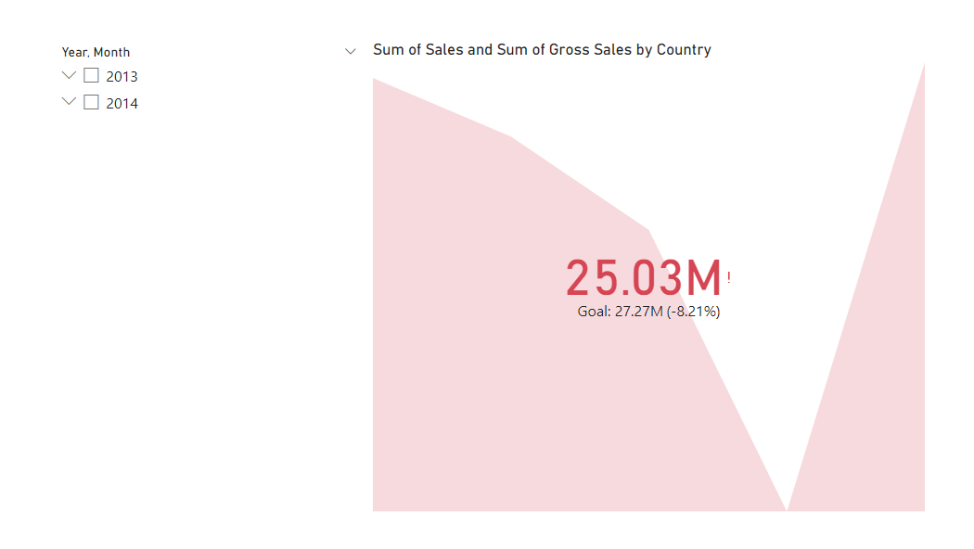

Line Chart & Clustered Bar Chart

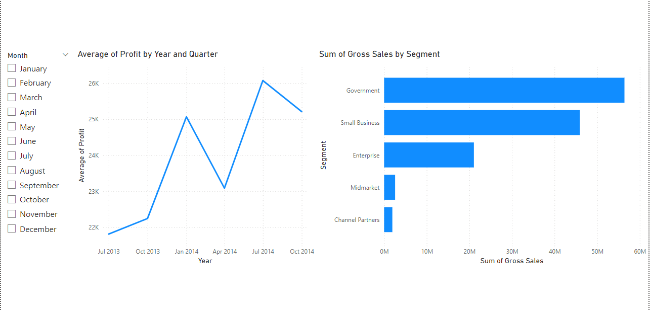

Stacked Bar Chart & Pie Chart

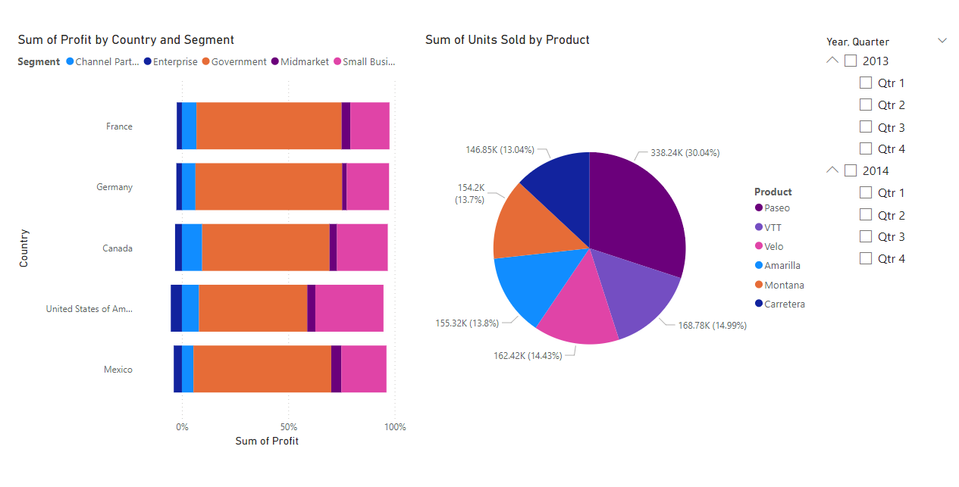

Ribbon Chart & Key Influencers

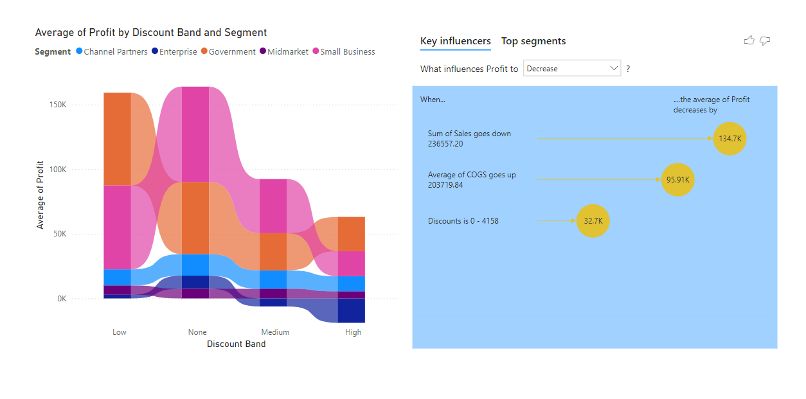

Funnel Chart & Line Chart

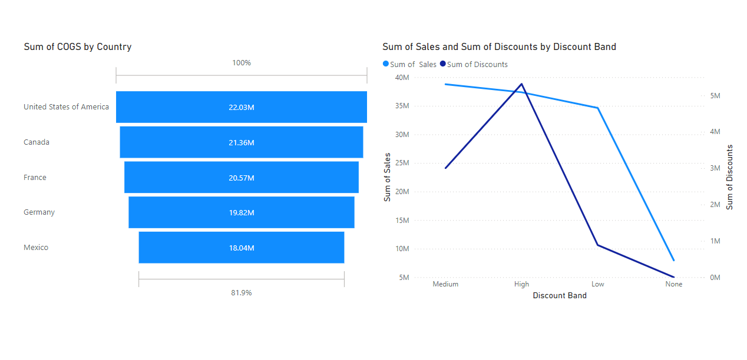

Scatter Plot

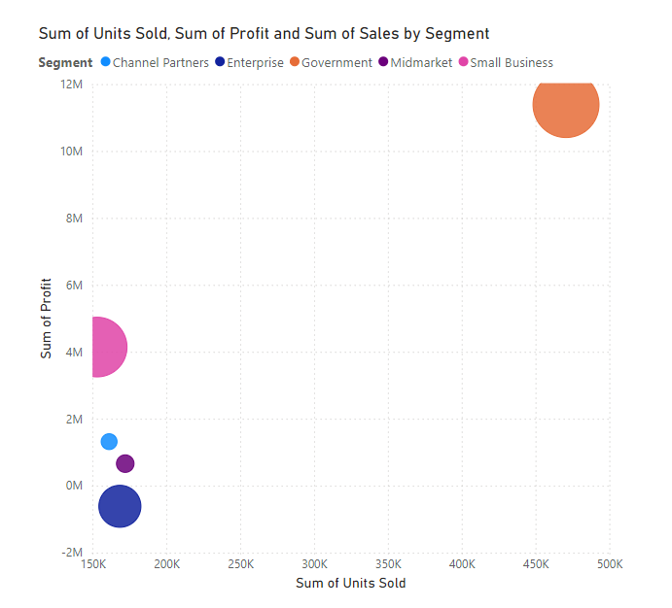

**Challenges and Learnings**

The journey of developing the “**Financial Forecasting Dashboard using Power BI**” was both challenging and rewarding. Each phase of the project presented unique obstacles, pushing the boundaries of technical expertise and analytical thinking. Overcoming these challenges resulted in invaluable learning experiences, both in terms of technical skills and problem-solving capabilities.

**Challenges Faced**

1. **Data Preprocessing Challenges**
   * **Inconsistent Data Formats**: The historical financial dataset contained inconsistencies, such as varying date formats, missing values, and unstructured columns. These issues required significant time and effort to standardize before analysis.
   * **Missing and Duplicate Values**: Missing entries in critical columns like "Units Sold" and "Profit" disrupted calculations. Duplicate rows created redundancy, necessitating thorough cleaning to ensure accuracy.
   * **Handling Outliers**: Certain entries in the dataset, such as abnormally high or low sales figures, skewed results and required careful handling to avoid misleading insights.

*Resolution*: These issues were addressed using Power Query’s data-cleaning tools. Missing values were estimated through interpolation, duplicates were removed, and outliers were treated based on domain knowledge and statistical methods.

1. **Learning Curve with Power BI**
   * **Understanding Advanced Features**: While Power BI is user-friendly for basic visualizations, mastering advanced features like DAX calculations and custom measures was initially challenging. Complex formulas, such as time intelligence functions and dynamic measures, required deep exploration.
   * **Custom Forecasting Models**: Building custom forecasts using DAX and Power Query demanded a strong understanding of both tools, as well as creativity in applying them to real-world scenarios.

*Resolution*: Extensive documentation, tutorials, and experimentation were key to mastering these tools. Hands-on practice with sample datasets and regular feedback from mentors helped overcome the learning curve.

1. **Designing an Intuitive Dashboard**
   * **Balancing Detail and Simplicity**: The challenge was to present complex financial data in a way that was both informative and easy to interpret. Overloading the dashboard with too many visualizations risked overwhelming the end-users, while oversimplifying it could obscure critical insights.
   * **Ensuring Interactivity**: Creating dynamic filters and slicers that worked seamlessly across all visualizations required careful configuration to avoid performance issues.

*Resolution*: Iterative design and user feedback played a crucial role in optimizing the dashboard layout. By prioritizing key metrics and arranging visuals logically, the dashboard achieved a balance between functionality and clarity.

1. **Forecasting Accuracy**
   * **Model Validation**: Ensuring the reliability of forecasting models was a significant challenge. The initial forecasts produced by Power BI’s built-in tools often deviated from historical trends, especially in scenarios involving rapid market fluctuations.
   * **Adjusting Parameters**: Configuring forecast lengths, confidence intervals, and seasonality settings required detailed experimentation to align predictions with actual trends.

*Resolution*: To improve accuracy, the forecasts were cross-validated with historical data, and custom calculations were implemented to address specific anomalies.

1. **Time Constraints**
   * The scope of the project demanded simultaneous attention to multiple tasks, including data preparation, visualization, forecasting, and dashboard design. Balancing these tasks within the internship timeline required meticulous planning and prioritization.

*Resolution*: A milestone-based approach, breaking the project into manageable phases, helped streamline the workflow and ensure timely completion of each module.

**Learnings**

1. **Technical Proficiency**
   * **Power BI Expertise**: The project deepened my understanding of Power BI, particularly its advanced features like DAX, Power Query, and forecasting tools. I learned to handle large datasets efficiently and create compelling visualizations tailored to specific business needs.
   * **Time-Series Analysis**: Gained practical experience in analyzing and visualizing time-series data, a critical skill for financial forecasting.
   * **Forecasting Models**: Learned to implement and fine-tune both built-in and custom forecasting models, understanding their limitations and potential enhancements.
2. **Analytical Thinking**
   * **Problem Solving**: Overcoming challenges like data inconsistencies and forecasting accuracy required innovative thinking and iterative experimentation.
   * **Data-Driven Insights**: The project taught me how to derive actionable insights from raw data, connecting trends and metrics to real-world business implications.
3. **Project Management**
   * **Time Management**: Balancing multiple responsibilities within tight deadlines honed my organizational and planning skills. I learned to prioritize tasks based on their complexity and importance.
   * **Collaboration and Feedback**: Regular interactions with mentors and peers improved the project significantly. Incorporating their feedback into the dashboard design and forecasts was a valuable learning experience.
4. **Soft Skills**
   * **Communication**: Presenting complex data and insights in a simplified manner through the dashboard improved my ability to communicate technical information effectively.
   * **Attention to Detail**: Ensuring data accuracy and dashboard usability emphasized the importance of precision in analytics projects.

**Summary**

The challenges encountered during this project were diverse, ranging from technical issues to time management hurdles. However, each obstacle provided an opportunity to learn and grow, ultimately contributing to the success of the project.

**Conclusion**

The “Financial Forecasting Dashboard using Power BI” project was a comprehensive exploration of data analytics, visualization, and forecasting in the financial domain. By leveraging historical data, advanced analytical tools, and interactive dashboards, the project achieved its primary objective of providing actionable insights into financial performance.

The implementation process began with meticulous **data preparation**, where inconsistencies were addressed to ensure accuracy and reliability. This was followed by the creation of meaningful visualizations that highlighted **trends** in revenue, expenses, and profitability. The development of forecasting models enabled the **prediction** of future financial outcomes, equipping stakeholders with the foresight needed to make informed decisions. Finally, all insights were consolidated into an interactive, user-friendly **dashboard** that serves as a one-stop solution for analyzing historical data, monitoring current performance, and planning future strategies.

The project also demonstrated the immense **potential** of Power BI as a business intelligence tool. Its capabilities for dynamic filtering, real-time data integration, and interactive visualization make it an indispensable resource for organizations aiming to harness the power of data. The custom calculations and models implemented using DAX and Power Query further enhanced the depth of analysis, showcasing the flexibility and scalability of the platform.

Through this project, I have gained a deeper understanding of financial analysis, time-series forecasting, and data visualization. The experience has honed my technical skills, problem-solving abilities, and understanding of the nuances of presenting complex data in an accessible format.

The **success** of this project underscores the importance of data-driven decision-making in today’s competitive business environment. The interactive dashboard not only simplifies complex data analysis but also empowers users with insights that drive strategic growth. While the project achieved its intended objectives, it also laid the groundwork for further innovation and enhancement, paving the way for more sophisticated financial forecasting solutions.

**Future Scope**

While the project successfully achieved its goals, there are several areas for improvement and expansion that could significantly enhance the dashboard’s functionality and analytical capabilities. These enhancements are outlined below:

**1. Real-Time Data Integration**

One of the most impactful upgrades would be integrating the dashboard with real-time data sources. This would enable continuous updates to financial metrics, allowing users to monitor performance and make decisions based on the most current information. Real-time integration can be achieved through connections to live databases or APIs, ensuring that the dashboard reflects ongoing changes in revenue, expenses, and profits.

**Benefits**:

* Immediate access to current financial data.
* Better responsiveness to market fluctuations.
* Enhanced decision-making accuracy in dynamic environments.

**2. Advanced Forecasting Models**

The project utilized Power BI’s built-in forecasting tools and custom DAX calculations for predictions. However, incorporating advanced machine learning (ML) algorithms could significantly improve forecasting accuracy, especially for complex scenarios. Tools like Python or R could be integrated into the Power BI workflow to build predictive models that account for multiple variables and external factors.

**Potential Models**:

* Time-series models such as ARIMA or Prophet for more sophisticated trend analysis.
* Regression models for identifying the impact of external factors like market conditions or seasonality.
* Neural networks for capturing non-linear relationships in the data.

**Benefits**:

* Improved forecast reliability.
* Greater flexibility to adapt to varying business contexts.
* Ability to include external data sources for more comprehensive predictions.

**3. Expansion of Financial Metrics**

Currently, the dashboard focuses on key metrics such as revenue, expenses, and profit. Adding additional financial indicators could provide a more holistic view of organizational performance. Examples include:

* **Return on Investment (ROI)**: To evaluate the efficiency of investments.
* **Cash Flow Analysis**: To monitor liquidity and operational health.
* **Break-Even Analysis**: To determine the minimum performance needed to avoid losses.

**Benefits**:

* Deeper insights into financial stability.
* Support for long-term strategic planning.
* Enhanced ability to assess the impact of financial decisions.

**4. Improved Interactivity and User Experience**

Enhancing the interactivity of the dashboard could make it even more user-friendly and engaging. Features like drill-through capabilities, tooltips with detailed metrics, and customizable dashboards could significantly improve usability.

**Suggestions**:

* Allow users to create their own reports by selecting specific metrics or time periods.
* Add drill-through features to explore granular data for specific regions, products, or time frames.
* Introduce advanced tooltips that provide deeper insights when hovering over visuals.

**Benefits**:

* Greater flexibility for end-users.
* Improved accessibility for stakeholders with varying levels of technical expertise.

**5. Multi-Dimensional Analysis**

The current dashboard allows for analysis across a few dimensions, such as time, region, and product. Expanding this capability to include additional dimensions—such as customer demographics or sales channels—could unlock new insights.

**Benefits**:

* Better understanding of customer behavior and preferences.
* Identification of high-performing sales channels.
* Insights into market segmentation for targeted strategies.

**6. Scalability and Deployment**

Deploying the dashboard on a larger scale could involve publishing it to the Power BI Service or embedding it into organizational portals. This would allow more stakeholders to access the dashboard and collaborate effectively. Furthermore, mobile optimization could make the dashboard accessible to users on the go.

**Benefits**:

* Increased accessibility and collaboration.
* Seamless integration into existing workflows.
* Enhanced user adoption across the organization.

**Summary**

The future scope of this project highlights its potential to evolve into a more advanced and impactful tool for financial analysis and forecasting. By integrating real-time data, adopting machine learning models, expanding metrics, and improving user interactivity, the dashboard can become a vital asset for organizations aiming to stay ahead in a data-driven world. These enhancements will not only refine the current capabilities but also ensure that the dashboard remains relevant and scalable for future business needs.

**References**

[1] Power BI Official Documentation: <https://learn.microsoft.com/en-us/power-bi/>

[2] Infosys Springboard